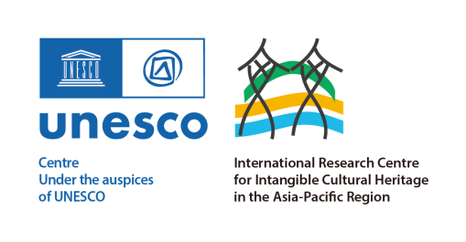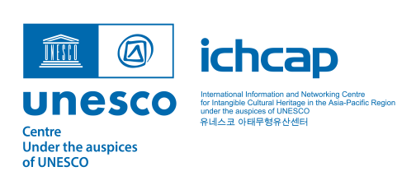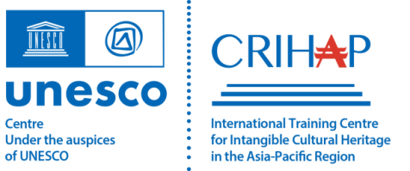

Open Call for

Cases on ICH Safeguarding

& Sustainable Development

in Asia-Pacific Region

（2024）

|  |
| --- |
| **Application Form** |
| Note:   1. Do not make any modifications to the form format when filling in the application; 2. Please submit the completed form no later than 12:00 noon on August 31, 2024（UTC+8）. |
| **A．General Information** |
| 1. About the case (practice) under application |
| a1. Name of the case (practice): |
| a2. ICH element(s) and community (or communities) concerned: |
| a3. Related ICH domains : |
| ☐ oral traditions and expressions, including language as a vehicle of the ICH  ☐ performing arts  ☐ social practices, rituals and festive events  ☐ knowledge and practices concerning nature and the universe  ☐ traditional craftsmanship |
| b. About the institution(s) and organization(s) involved in the application |
| Note:   1. Please indicate the name of the institution as the main implementer of the case;   2. Please Indicate other Participating institutions in Section B2 and B3, if there is any. |
| b1. Name of the institution as the main implementer of the case： |
| b2. Name(s) of the participating institution(s) (if any): |
| c. Contact information |
| c1. Name of the contact person: |
| c2. Institution/Position: |
| c3. Telephone number: |
| c4. Email address: |
| c5. Mailing Address: |
| c6.Letter of Undertaking: |
| Statement  I/The institution hereby guarantee(s) the authenticity and accuracy of the information and materials provided, and confirm(s) the case (practice) presented here is indeed executed by myself /the institution.  I/The institution acknowledge(s) and pledge(s) to comply with the above content.    Signature:  (Stamp)  Date: |
| **B. Executive Summary of the case under application**  NOTE:   1. 1. The case refers to the inheritance and safeguarding activities or practices carried out around a specific ICH element; 2. 2. The case should be closely related to sustainable development (see the 17 SDGS listed in table B. b); 3. 3. The case can be either completed practices and activities, or practices, activities and programs in the process of implementation (programs that have not been started are not included). |
| a. Please indicate briefly the origin and objectives of the implementation of the case (practice) under application, the methods and initiatives adopted, and the ICH element(s) concerned and the beneficiary community or communities（No more than 800 words）. |
|  |
| b. Please indicate how this case relates to the Sustainable Development Goals (how this case contributes to sustainable development) |
| b1. Please tick off the goals applicable to the case (no more than 3 options) |
| 1. ☐ No Poverty 2. ☐ Zero Hunger 3. ☐ Good Health And Wellbeing 4. ☐ Quality Education 5. ☐ Gender Equality 6. ☐ Clean Water and Sanitation 7. ☐ Affordable and Clean Energy 8. ☐ Decent Work and Economic Growth 9. ☐ Industry, Innovation and Infrastructure 10. ☐ Reduced Inequalities 11. ☐ Sustainable Cities and Communities 12. ☐ Responsible Consumption and Production 13. ☐ Climate Action 14. ☐ Life Below Water 15. ☐ Life On Land 16. ☐ Peace, Justice and Strong Institutions 17. ☐ Partnerships for the Goals |
| b2. Brief Description |
| NOTE: PLEASE INDICATE HOW THE CASE PROMOTES THE ACHIEVEMENT OF THE SELECTED GOALS (NO MORE THAN 800 WORDS). |
|  |
| C. The contribution of this case (practice) to the inheritance and safeguarding of the ICH element concerned |
| NOTE: SELECT AT LEAST ONE ITEM IN THE TABLE BELOW AND ANSWER CORRESPONDING QUESTIONS IN ACCORDANCE WITH THE CIRCUMSTANCES OF THE CASE(PRACTICE) UNDR APPLICATION . |
| **Raising Awareness**  Please indicate the achievements made in *raising awareness* through the implementation of the case under application from the following perspectives (200-800 words) |
| 1. Whether the implementation of the case has enhanced the visibility and proper understanding of the ICH element concerned; 2. Whether the implementation of the case has highlighted the value and significance of the ICH element concerned; 3. Whether the implementation of the case has contributed to fostering a sense of belonging and purpose. |
|  |
| **Improving Resilience** Please indicate the achievements made in *improving resilience* through the implementation of the case under application from the following perspectives (200-800 words). |
| 1. Whether local communities, groups or individuals are the primary beneficiaries of the case; 2. Whether the implementation of the case has contributed to the improvement of local livelihoods; 3. Whether the implementation of the case has promoted the integration of culture and tourism; 4. Whether the implementation of the case has contributed to "efficiency and equity" |
|  |
| **Promotion and Education** |
| Please indicate the achievements made in *promotion and education* through the implementation of the case under application from the following perspectives (200-800 words) |
| 1. Whether the implementation of the case has expanded the group of inheritors; 2. Whether the implementation of the case has attracted youth participation; 3. Whether the implementation case has contributed to the interaction between living heritage and education. |
| **Others (if any)** |
|  |
| **D. Photographs and videos as supporting materials** |
| 1. Technical Specifications   NOTE:  1.PHOTOS (REQUIRED) OR VIDEOS (OPTIONAL) AS WELL AS OTHER SUPPORTING MATERIALS THAT ARE NEEDED TO PROVE THE ELIGIBILITY OF THE CASE UNDER APPLICATION FOR SELECTION;  2.OTHER NECESSARY MATERIALS INCLUDING BUT NOT LIMITED TO RELEVANT VIDEOS, NEWS RELEASE AND ARTICLES IN SUPPORT OF THE AUTHENTICITY OF THE ICH ELEMENT CONCERNED (OPTIONAL);  3. TEXT DESCRIPTION FOR EACH PHOTO SUBMITTED; AT LEAST 5 CASE-RELATED PHOTOS (IN JPG FORMAT, 2M OR ABOVE), AND A VIDEO CLIP (IN MP4 FORMAT, 3 MINUTES OR LESS IN LENGTH, RESOLUTION OF 1920×1080 OR ABOVE, NO WATERMARK). |
| b. Letter of Consent  Dear Sir/Ma’am:  As the <Owner/Manager> of <name of the case under application>，I hereby grant permission to < International Training Centre for Intangible Cultural Heritage in the Asia-Pacific Region under the auspices of UNESCO > to use <name of the case under application>, photographs and/or videos attached to this application form, as well as other supporting materials, in its own publicity and promotion operations.  Authorized by  Name：  Institution/Position：  Signature:  Date: |
| NOTE: please contact INTERNATIONAL TRAINING CENTRE FOR INTANGIBLE CULTURAL HERITAGE IN THE ASIA-PACIFIC REGION UNDER THE AUSPICES OF UNESCO (CRIHAP) for further information  CONTACT PERSON: MS. CHEN XIAOXI  PHONE NUMBER: 0086-10-64896563  EMAIL ADDRESS: research@crihap.cn |